**1** The diagram shows a section through a leaf. Use information in the diagram and your own knowledge to answer the questions. Write the answer or the letter in the space provided.

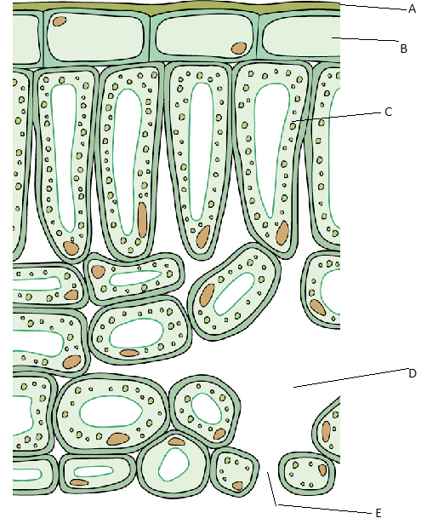

**a)** The region that carries out photosynthesis is labelled:

**A.** A

**B.** C

**C.** D

**D.** E (1)

**b)** Cells in layer B produce:

**A.** chloroplasts

**B.** waxy epidermis

**C.** waxy cuticle

**D.** water (1)

**c)** Which term best describes label E?

**A.** stoma

**B.** air space

**C.** guard cell

**D.** mesophyll (1)

**d)** Two important tissues are missing from the diagram. These tissues are found together in bundles. The tissues are:

**A.** xylem and palisade

**B.** palisade and cambium

**C.** xylem and phloem

**D.** epidermis and stomata (1)

**2** The diagram shows a simple piece of apparatus called a potometer. An air bubble was introduced into the potometer. The bubble started at 0 and the potometer was left for 20 minutes.

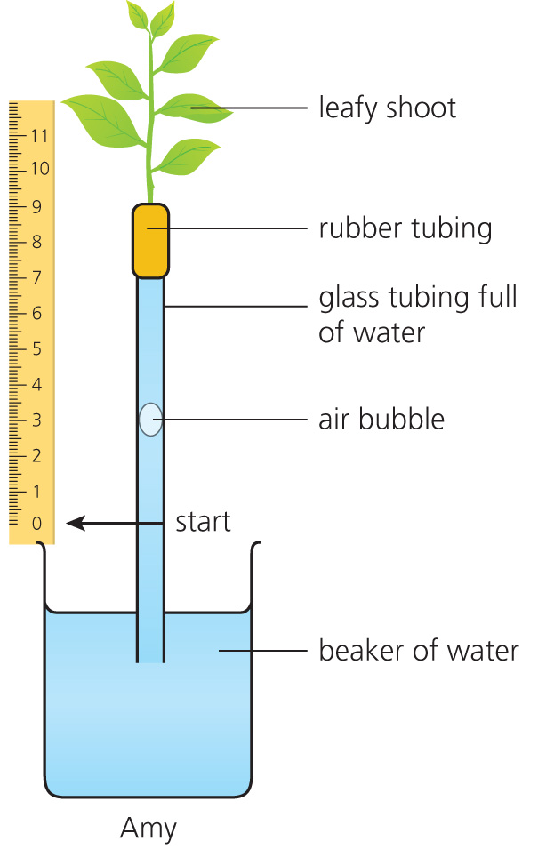

**a)** If the air bubble starts at time 0 on the ruler, how far has it travelled in 20 minutes? (2)

**b)** What is the rate at which the bubble is moving? (rate = distance/time) (2)

**c)** What is the name of the process which is pulling the bubble up the tube? (1)

**d)** Explain how this process is able to pull the bubble upwards. (3)

**e)** **i)** Name a factor that would make the bubble move faster. (2)

**ii)** How could the apparatus could be altered to change only the factor described in **i)**? (2)

**iii)** Explain why the bubble will now move faster. (3)

**f)** The table shows the results from four students who carried out the experiment with identical potometers.

|  |  |  |  |  |
| --- | --- | --- | --- | --- |
| Student | Distance moved by bubble (cm) | | | |
| Repeat 1 | Repeat 2 | Repeat 3 | Mean |
| Sue | 2.1 | 2.0 | 2.2 | 2.1 |
| Nicky | 1.4 | 1.5 | 1.6 | 1.5 |
| Giles | 2.0 | 2.3 | 2.2 | 2.2 |
| Omar | 1.4 | 2.8 | 2.4 | 2.2 |

**i)** Why was it necessary to repeat experiments at least three times? (2)

**ii)** Nicky’s results were consistently lower than the other students. Explain what sort of error Nicky made compared with the other students? (2)

**iii)** Which of Omar’s results is anomalous? (1)

**iv)** Why did you choose this result? (1)

**v)** What type of error is this? (1)

**vi)** What technique may have caused this error in Omar’s result? (1)

**vii)** Identify one potential source of error in the apparatus and explain how it could be improved. (3)

**3** Plants can be infected by pathogens like viruses, bacteria and fungi.

**a)** Complete the right-hand side of the table by putting in the name of the type of pathogen that causes the diseases.

|  |  |
| --- | --- |
| Disease | Pathogen |
| *Pseudomonas syringae* |  |
| Tobacco mosaic |  |
| Rose black spot |  |
| Rice blast |  |

(4)

**b)** Nematodes and aphids also transmit diseases from one plant to another.

**i)** What is a nematode? (1)

**ii)** Name a plant disease that is transmitted by nematodes. (1)

**iii)** Aphids are tiny insects that infect garden plants. What two methods do gardeners use to reduce the number of aphids. (2)

**4** The paragraph describes how plants defend themselves against pathogens. Fill in the gaps with the most appropriate terms from the list below.

Plants are able to defend themselves against disease causing ……… . They have a protective outer layer of ……… cuticle. Older woody plants have a thick outer layer of dead cells called ……… . These layers also help them to reduce ……… loss. Some plants have spines or thorn which deter from ……… eating them.

Many plants produce ……… chemicals. These toxins make the plant taste unpleasant. Some of the chemicals are very dangerous. ……… is a chemical produced by foxgloves. This powerful drug affects the heart rate. The drug is now used to treat irregular. heart rate in patients. (7)

**herbivores   digitalis   pathogens   bark   waxy   water   poisonous**

**5** Plants need small amounts of mineral ions to grow properly.

**a)** Name the ions needed for:

**i)** protein synthesis

**ii)** chlorophyll production (2)

**b)** How do plants take in mineral ions? (1)

**c)** What is chlorosis and why does it occur? (2)

TOTAL = 50

**1 a)** B

**b)** C

**c)** A

**d)** C (1 mark each = 4)

**2** **a)** 4 cm (allow 3.8–4.1 cm) (1 mark for answer and 1 for units = 2)

**b)** Distance moved = 4 cm; time = 20 minutes. Rate = 0.2 cm per minute. (1 for calculation, 1 for answer = 2)

**c)** transpiration/evaporation (1)

**d)** Leafy shoot in the glass tube is transpiring/losing water vapour; water evaporates out of the leaf cells/air spaces; as water is lost from the cells; it is replaced with water from the xylem in the stem; transpiration creates a suction which pulls water up. (1 mark per point = 3)

**e)** **i)** Increased temperature; increased wind speed. (1 mark for increase/decrease; 1 for factor = 2)

**ii)** Do not change any other factors; put plant in warm place; place electric fan near plant.

(1 mark for keeping factors constant; 1 for making the change = 2)

**iii)** Increased temperature; increased kinetic energy of particles; particles of water vapour move away from plant faster

OR

Increased air movement; increased speed of water vapour particles; particles of water vapour move away faster. (1 mark per point = 3)

**f)** **i)** Repeated results are more reliable; to check reliability; to calculate a mean; single results may be flawed. (2)

**ii)** Systematic error. The error was repeated in each experiment Nicky did. (2)

**iii)** 1.4 (repeat 1) (1)

**iv)** It is much lower than any of his other results (1)

**v)** random error (1)

**vi)** mistake reading the instrument or uncontrolled change in environment (1)

**vii)** apparatus not airtight; joints may leak; smear Vaseline round rubber joint (3)

**3 a)**

|  |  |
| --- | --- |
| Disease | Pathogen |
| *Pseudomonas syringae* | **Bacterium** |
| Tobacco mosaic | **Virus** |
| Rose black spot | **Fungus** |
| Rice blast | **Fungus** |

(1 mark each = 4)

**b) i)** a roundworm (1)

**ii)** potato cyst (1)

**iii)** Spray with insecticide; introduce predator like ladybird to eat aphid. (2)

**4** Plants are able to defend themselves against disease causing **pathogens**. They have a protective outer layer of **waxy** cuticle. Older woody plants have a thick outer layer of dead cells called **bark**. These layers also help them to reduce **water** loss. Some plants have spines or thorns which deter from **herbivores** eating them.

Many plants produce **toxic** chemicals. These toxins make the plant taste unpleasant. Some of the chemicals are very dangerous. **Digitalis** is a chemical produced by foxgloves. This powerful drug affects the heart rate. The drug is now used to treat irregular heart rate in patients.

(1 mark each = 7)

**5 a)** **i)** nitrates

**ii)** magnesium (2)

**b)** In solution through root hairs. (1)

**c)** The plant leaves turn yellow; caused by lack of magnesium. (2)

TOTAL = 50